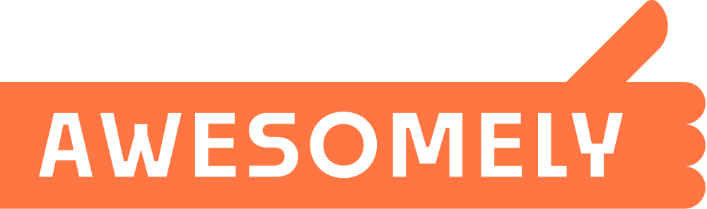

IMPORTANT DISCLAIMER:

This form is provided 'AS-IS' without any warranty of any kind, expressed or implied, statutory or otherwise. Any use of this form is at your own risk.

While the information contained herein is designed to provide accurate and authoritative information in regard to the subject matter covered, it is offered with the understanding that the presenter(s) are not engaged in rendering legal, accounting, or other professional service. If legal advice or other expert advice is required, the services of a competent professional should be sought.

Personal Note from JP:

If your tenants are late with the rent, you need to get their attention. And sometimes a phone call just isn’t enough. Try sticking one of these puppies (in full color) RIGHT TO THEIR FRONT DOOR.

Trust me, you’ve now got their attention.

YOU ARE LATE !

Your rent for January 2023 has not been paid! If we have not received your rent payment in full (INCLUDING LATE CHARGE) by January 11th, 2023, we will begin immediate eviction proceedings!

Remit your rent + late fee immediately to:

Oaks Management Group, LLC
Suite 671
1910 Madison Ave.
Memphis, TN 38104-2620

Or contact our Property Manager:
Johnpaul Moses, (901) 756-0000

- If received by 1/5/23, amount due is: $640.00 + $25.00 = $665.00
- For each day after the 5th, add $5.00 for each additional day (see lease).
- All payments received are applied first to late charges, then to rent owed.

